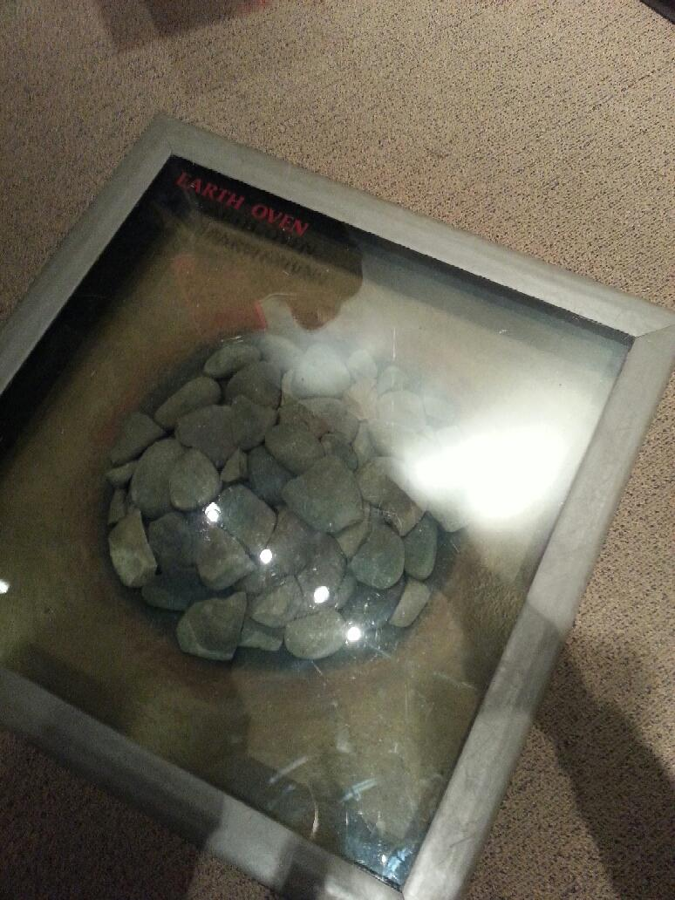
The Native American “Earth Oven” otherwise known as a fire pit that is used to cook food for the community.
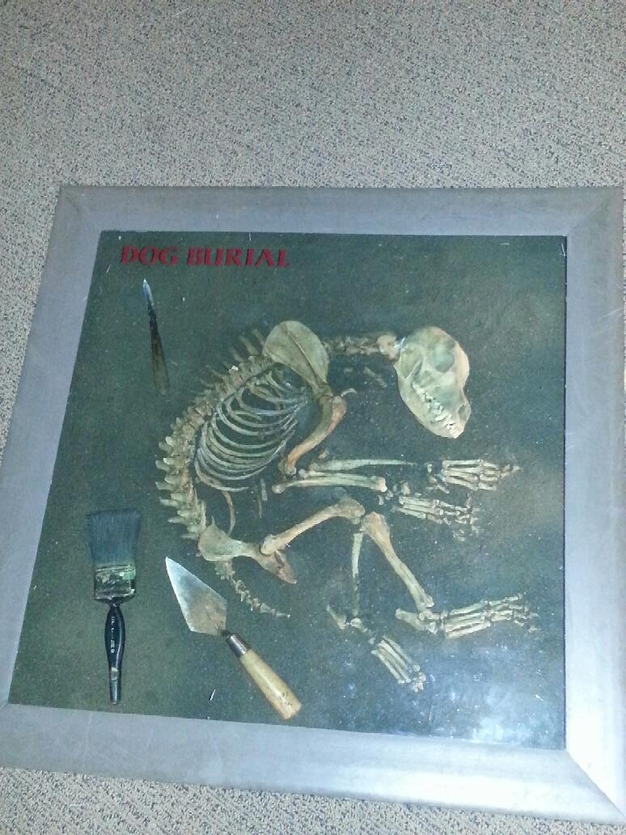
A Native American dog burial that symbolizes the importance of animals to Native Americans and the respect Native Americans shared for animals, including inviting them to a happy afterlife with a proper burial.
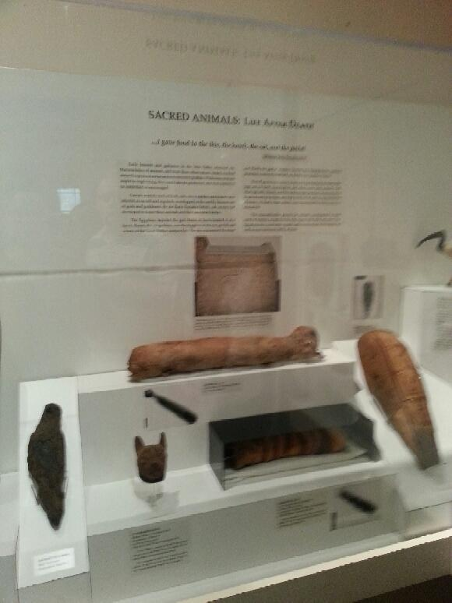

Ancient Greek also thought highly of their animals, inviting them to the afterlife as well. The burial was different than the Native Americans though. Ancient Egyptian’s mummified some of their animals, just as they mummified the important people of their culture.
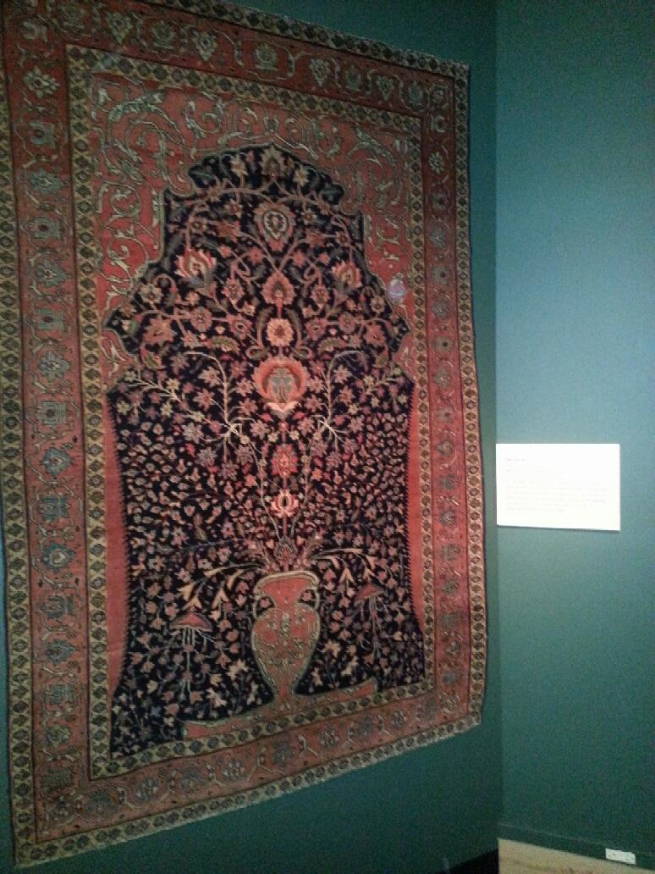
A prayer rug from West Central Iran that would be used during the five Islamic required prayers throughout the day.
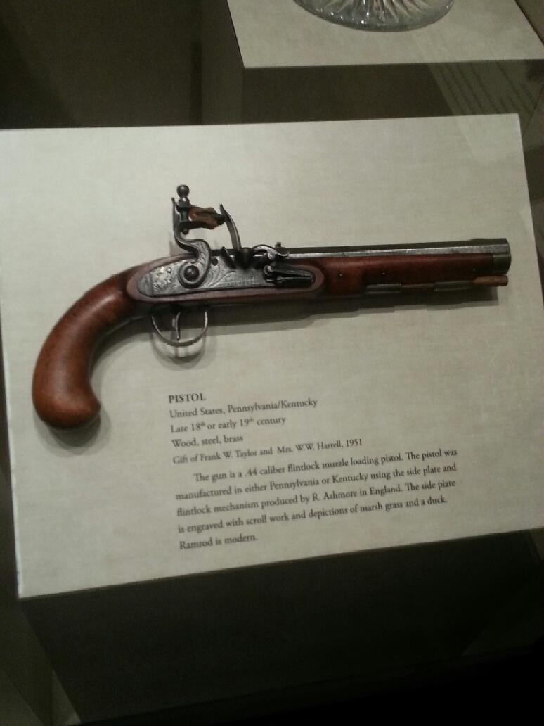
A pistol from the United States during the late 18th or early 19th century.
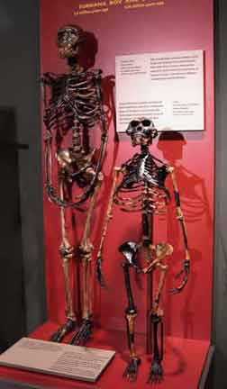
These skeletons are some of the earliest bone remains found of the human species. Named “Lucy” and the “Turkana Boy.” The boy seems only around the age 12 and Lucy seems to have full grown woman characteristics although she has a short rib cage, small head exhibiting a small brain, abnormally large arms and short legs.

